Homework 4 - Worked example

## Warning: Mixed within-and-between-Ss effect requested; FLSD is only appropriate for within-Ss comparisons (see warning in ?ezStats or ?ezPlot).  
## Warning: Collapsing data to cell means first using variables supplied to "within_full", then collapsing the resulting means to means for the cells supplied to "within".

In order to evaluate the effect of study breed, fish content, and beef content on cat food consumpton, we performed a 2x2x4 mixed ANOVA with amount food eaten (in g) as the dependent variable and breed (Shorthair vs. Persian vs. Siamese vs. Manx), fish content of the cat food (fish vs. no fish), and beef content of the cat food (beef vs. no beef) as independent variables. Table 1 and Figure 1 show the condition means.

*Table 1. Means, sample sizes (N), standard deviations (SD), and standard errors (SE) for the breeds and cat food conditions.*

|  |  |  |  |  |  |  |
| --- | --- | --- | --- | --- | --- | --- |
| Breed | Fish | Beef | N | Mean | SD | SE |
| Manx | no | no | 10 | 88 | 36 | 11.5 |
| Manx | no | yes | 10 | 116 | 40 | 12.7 |
| Manx | yes | no | 10 | 135 | 41 | 13.0 |
| Manx | yes | yes | 10 | 108 | 35 | 11.1 |
| Persian | no | no | 10 | 60 | 24 | 7.6 |
| Persian | no | yes | 10 | 86 | 24 | 7.7 |
| Persian | yes | no | 10 | 106 | 20 | 6.3 |
| Persian | yes | yes | 10 | 75 | 21 | 6.6 |
| Shorthair | no | no | 10 | 56 | 22 | 7.0 |
| Shorthair | no | yes | 10 | 78 | 21 | 6.6 |
| Shorthair | yes | no | 10 | 98 | 22 | 6.9 |
| Shorthair | yes | yes | 10 | 63 | 17 | 5.4 |
| Siamese | no | no | 10 | 64 | 39 | 12.2 |
| Siamese | no | yes | 10 | 79 | 35 | 11.0 |
| Siamese | yes | no | 10 | 102 | 41 | 12.8 |
| Siamese | yes | yes | 10 | 69 | 42 | 13.3 |

*Figure 1. Condition means. Error bars denote 95% confidence intervals based on Fisher's Least Significant Difference.*

## Warning: Mixed within-and-between-Ss effect requested; FLSD is only  
## appropriate for within-Ss comparisons (see warning in ?ezStats or  
## ?ezPlot).

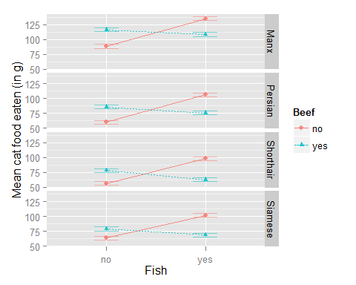

## Warning: Collapsing data to cell means first using variables supplied to  
## "within_full", then collapsing the resulting means to means for the cells  
## supplied to "within".

The ANOVA showed that overall, there was a significant main effect of fish content, *F*(1, 36) = 113.23 $η_{G}^{2}$ = 0.07, *p* < .01, with cats eating more food when there was fish in it. There also was a significant main effect of beef content, *F*(1, 36) = 8.63 $η_{G}^{2}$ = 0.01, *p* < .01, and a significant effect of breed, *F*(3, 36) = 3.21 $η_{G}^{2}$ = 0.2, *p* = 0.0343720051497151, with cats eating more food when there was beef in it. With regard to breed, there was no evidence that the homogeneity of variance assumption was violated (*p* > .05). The fish and beef main effects were modulated by a significant two-way interaction, *F*(1, 36) = 571.82 $η_{G}^{2}$ = 0.17, *p* < .01. This interaction showed that, when no beef was in the food, the cats ate more when there was fish in the food (mean eaten = 110 g) than when there was no fish (mean eaten = 67 g). When the food contained beef, cats ate less food when there was also fish in the food (mean eaten = 79 g) than when there was only beef (mean eaten = 90 g). None of the other interactions were significant(all *p*s > .05).

The Shapiro-Wilk test revealed no deviations from normality in the dependent variable (*p* > .05).

Post-hoc pairwise *t*-tests (Holm-Bonferroni corrected) showed that Manx cats ate more food overall (112 g) than Shorthair cats (74 g; p < .05). The difference between Manx cats and Persian cats (82 g) and Siamese cats (79 g) did not reach significance. None of the other comparisons were significant.

### Summary

Based on the results of our analyses, we can conclude that cats eat more food when it contains either fish or beef. However, cats don't seem to like it as much when their food contains both fish and beef together, as they eat less in that case. Cat breed does not seem to have an influence with regard to beef and fish preference. Some cat breeds (specifically, the Manx) do seem to eat more overall, but their preferences are the same as the other breeds'.